Coillte Supplier Management System

Contract Administration

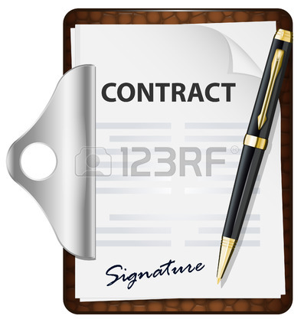

Information Guide SMS4

Introduction
Coillte introduced the Supplier Management system in 2013 to fully integrate and implement an electronic Purchase to Payment system including data management , e-tendering, contract authorisation, self invoicing and electronic payments system
Suppliers can use the system to complete all transactions with Coillte including:
- Register interest in doing business
- Maintain their master data and key documents
- Receive automatic notifications of Tenders
- Bid online for work
- Accept and authorise contracts electronically
- Generate invoices eletronically based on work certified/goods supplied
Information Guide
The purpose of this guide is to give suppliers a step by step approach as to how to use the SMS to authorise and store contracts with Coillte for goods and services

Support
If you require any help in accessing or using the Supplier Portal please contact the SMS support team whose details can be found on the Coillte Website www.coillte.ie
1.
Logging in and out of Supplier Portal

Logging In
You can access your Supplier Portal via the link on the Coillte Main website see section 1.1 or by clicking on the following link
https://supplierlive.proactisp2p.com/Account/Login
Enter your email address as your Username and your password to open your Supplier Portal account
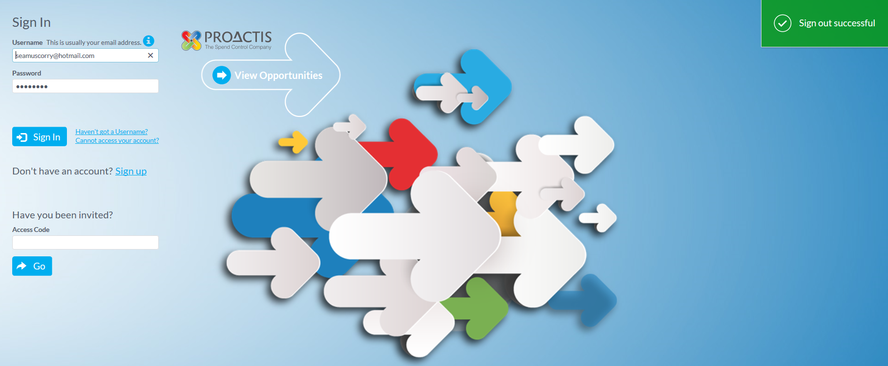

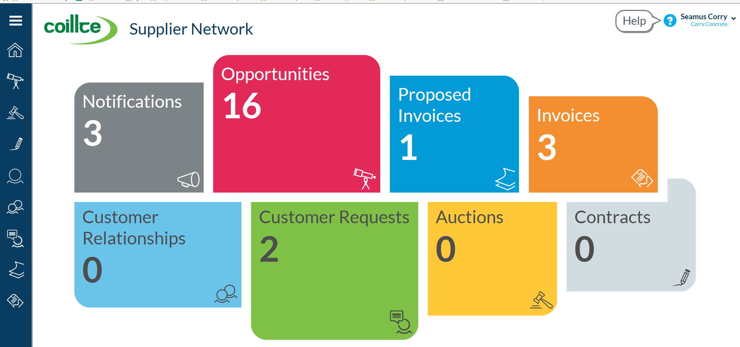

2.
Logging out
To log out select the drop down arrow on top right hand corner beside company name and click on sign out option to exit the system

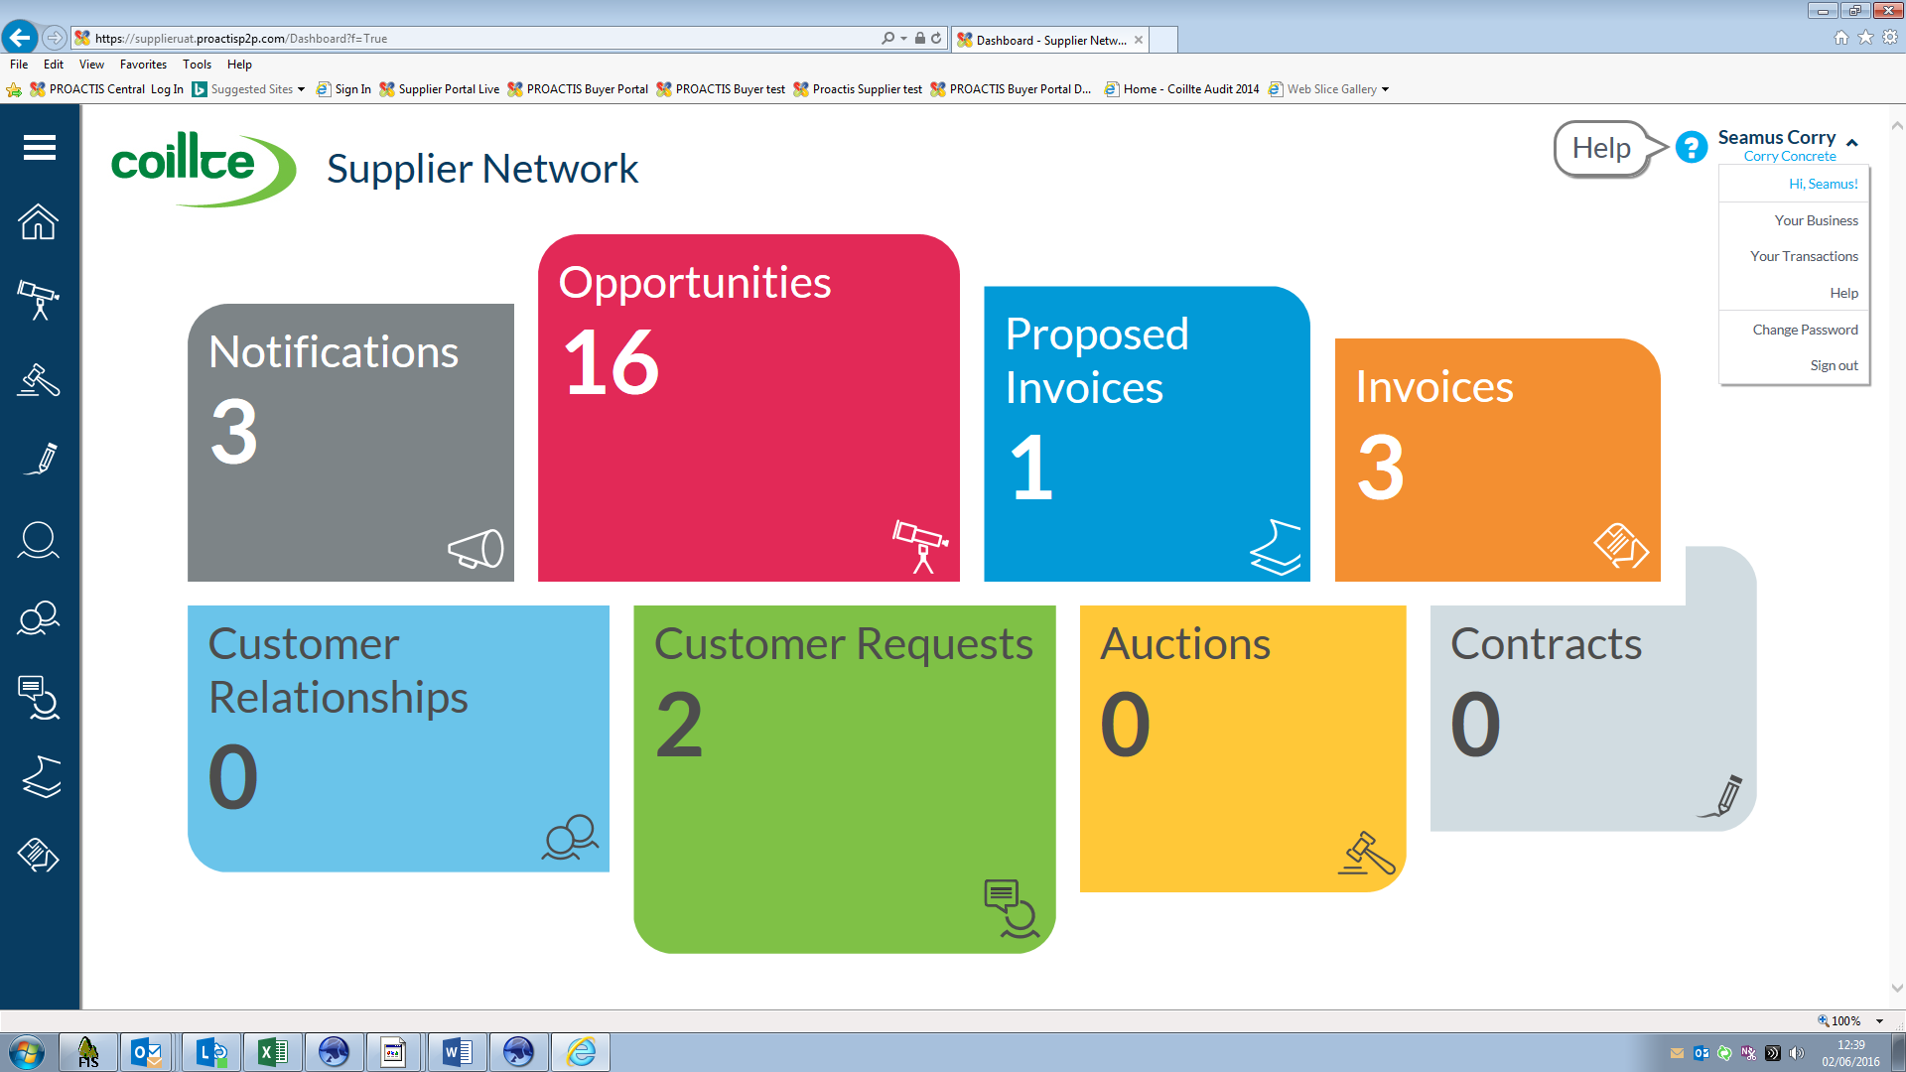

Forgot Username or Password
If you have any problems accessing the Supplier Portal please contact the SMS Support team or any member of the Accounts Payable team in Coillte at accountspayable@coillte.ie

3.
Contract Notification
Once a supplier is awarded a contract by Coillte following a tender competition etc. a contract document is generated by the Coillte Contract Manager and issued to the Supplier to authorise electronically via the Supplier Management System
Email sent to Supplier from Coillte
Supplier receives an email from Coillte notifying them that they have a contract pending for authorisation.
Supplier logs into Portal to view contract notification and the contract detail in the attachment and if they are happy to accept the contract they reply to the dialogue using legally accepted wording for contract authorisation as shown below
Contract Offer and Acceptance
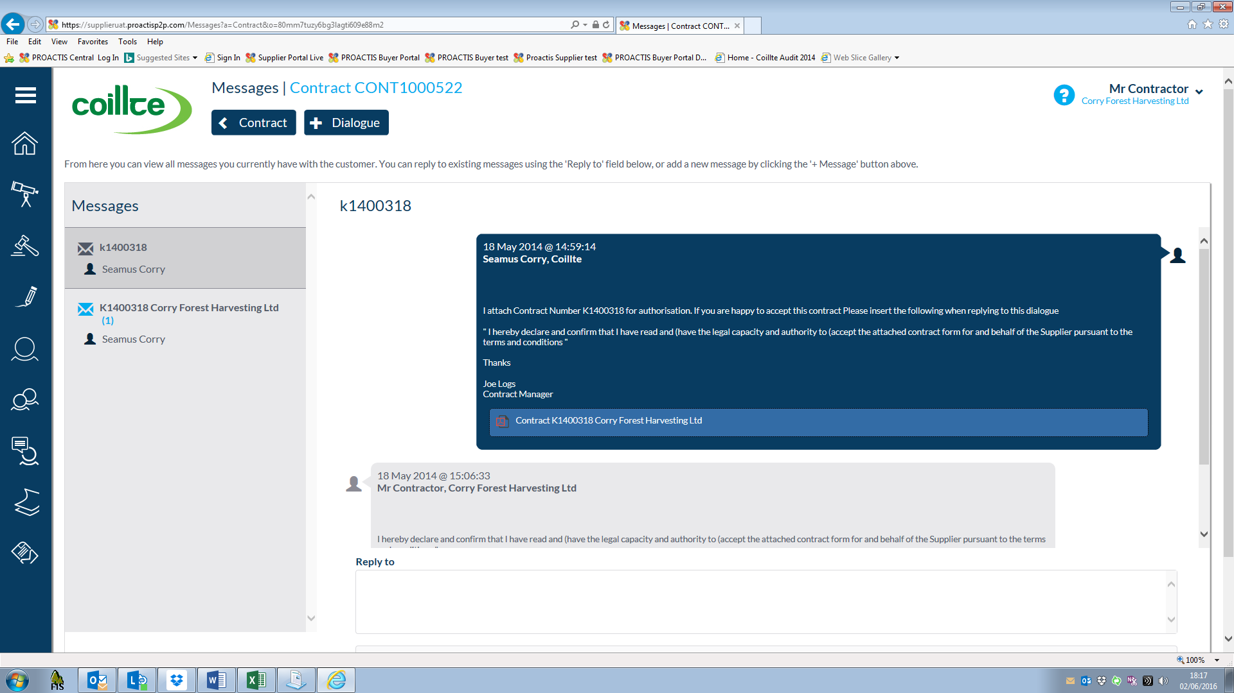
The Contract Administrator in Coillte is automatically notified when the Supplier has electronically accepted the contract and the contract is then authorised by the relevant manager in Coillte and is live and ready to be use

4.

Contract Storage
When you log into the Supplier Portal you will find a list of all your contracts with Coillte in the Contracts table
Click on this menu item
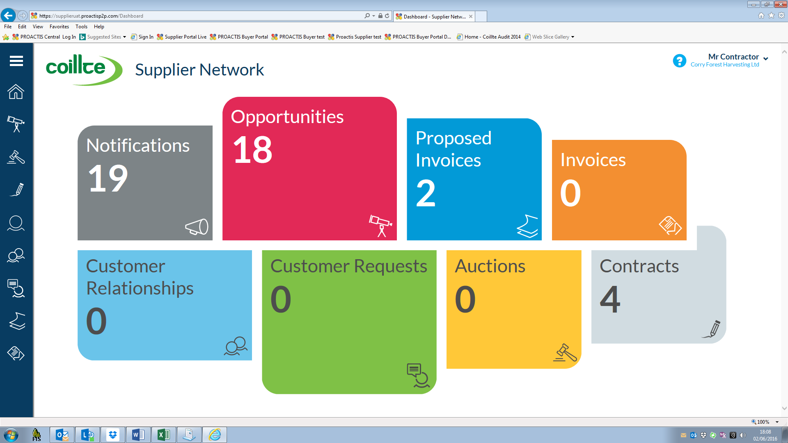
A list of contracts will display and you can access any contract detail using the show me arrows
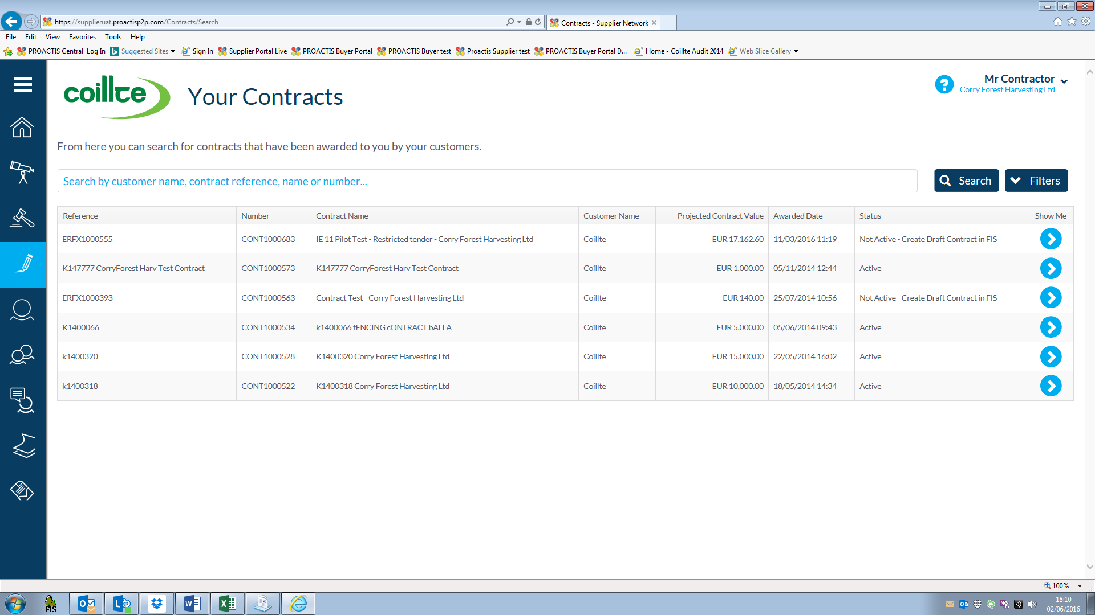

5.
Sample Coillte Standard Contract
Contractor Name and Address
6.

7.

