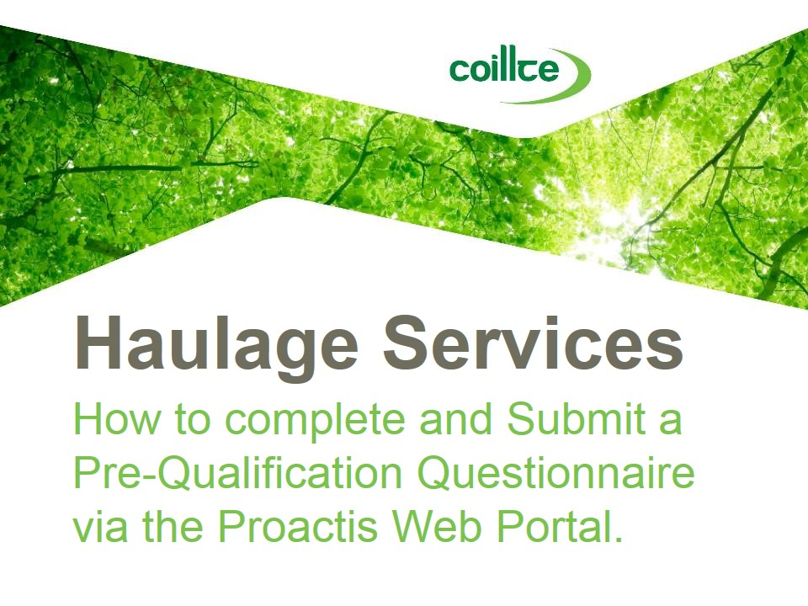 | - This presentation will provide guidance on how to complete and submit a Pre-Qualification Questionnaire on Coillte’s Supplier Management System, the Proactis Web Portal.  - Only PQQ’s submitted via the Proactis Web Portal will be considered for Haulage Services.  - If you pass the PQQ stage you will be invited to tender at a later date and at this point you will be asked to submit this tender via the Proactis Web Portal also.
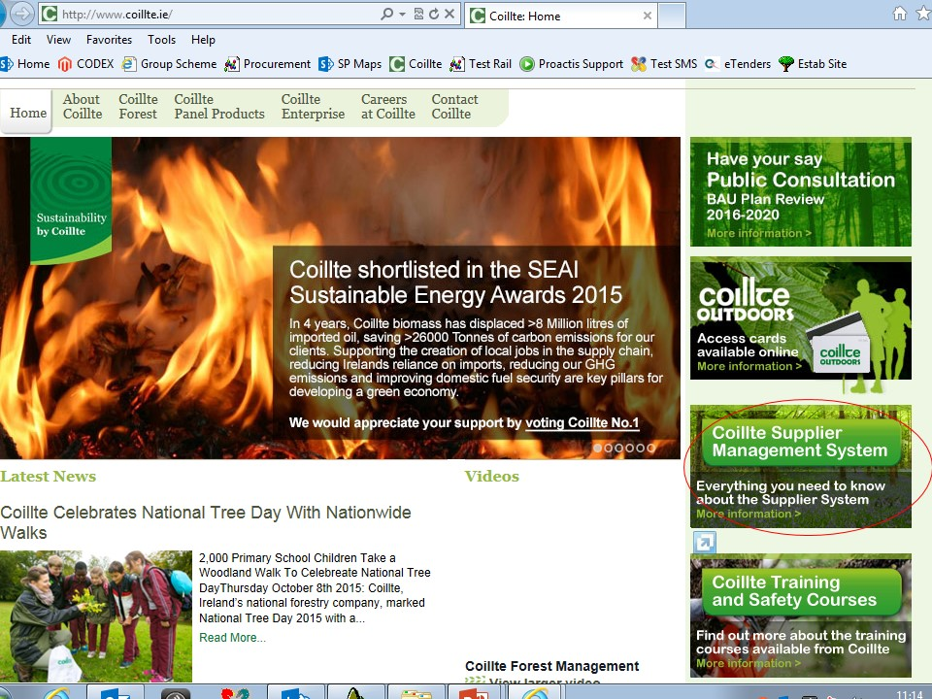 | - Coillte’s Supplier Management System can be accessed via the Coillte Website.  - When you enter Coillte’s website, click on the Coillte Supplier Management System button on the right of the home page, circled in red on this presentation.
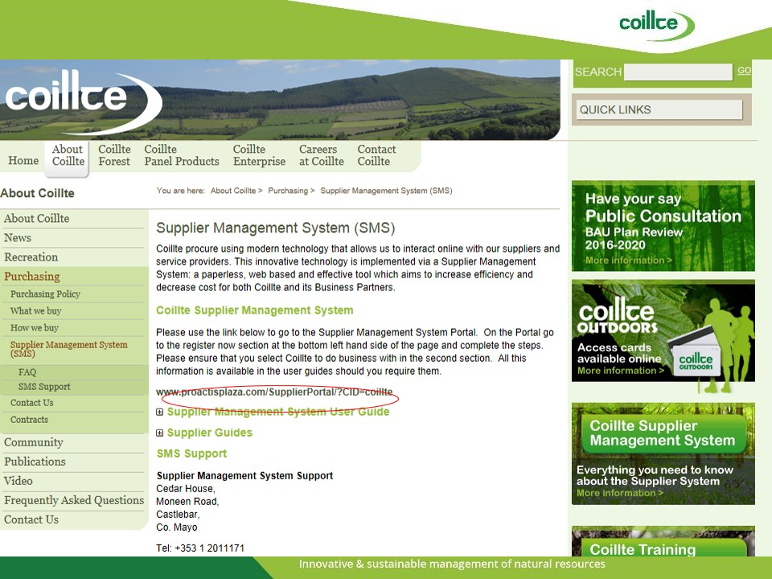 | - This will then bring you through to the Supplier Management System or SMS section of the website.  - There are many SMS user guides which you may find useful when navigating the Proactis Web Portal.  - To launch the Proactis Web Portal you will need to click on th web link www.proactisplaza.com, circled in Red in this presentation.
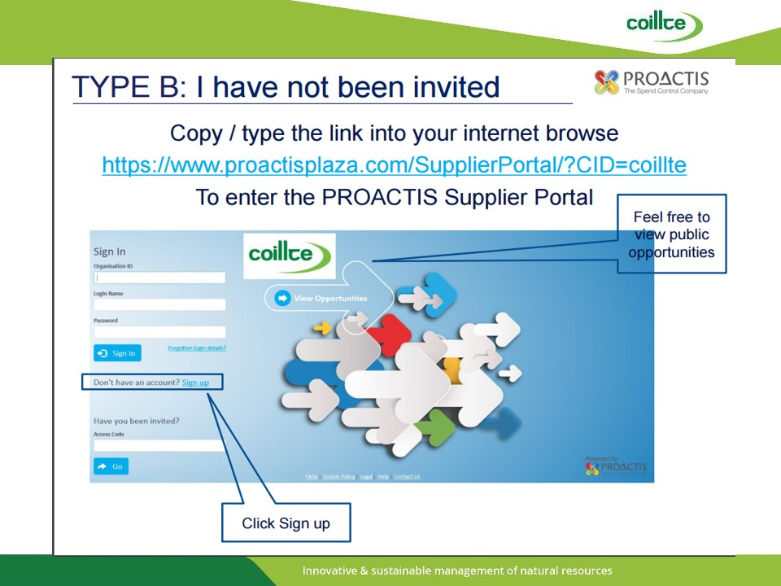 | - If you are not a registered user of the Proactis Web Portal, the following slides will help to guide you with the registration process.  - The SMS user guides on Coillte’s website that I have referred to previously will also provide more detailed guidance.  - To begin the registration process you must first click sign up as identified here.
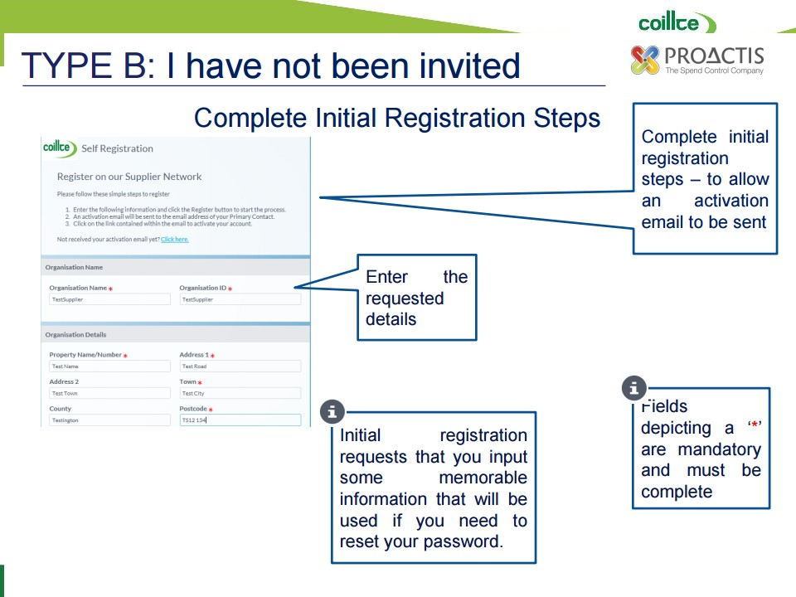 | - Next, you must complete the initial registration steps to allow an activation e-mail to be sent.  - Enter the requested details here and ensure that all mandatory fields marked by a red star are completed.
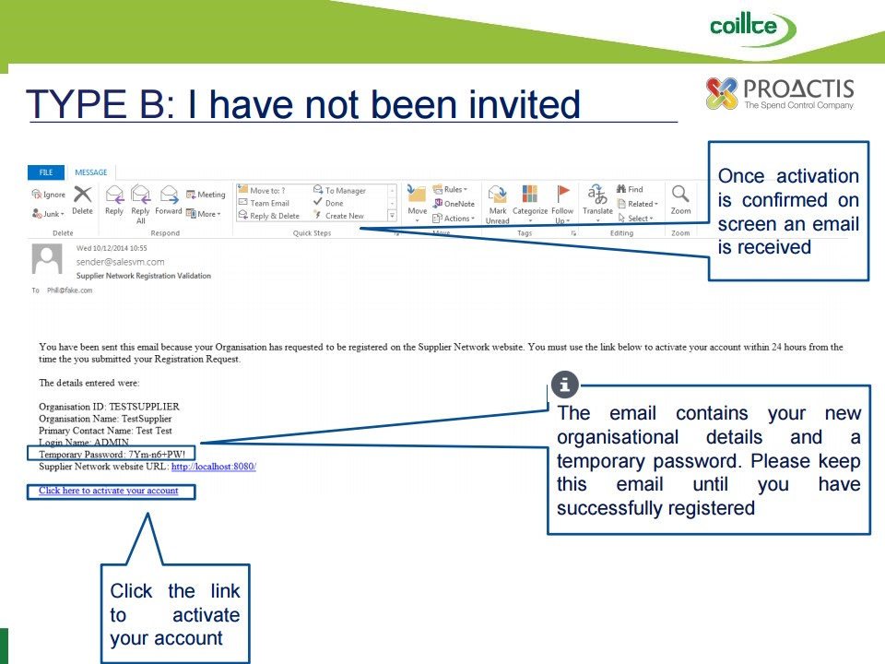 | - Once activation is confirmed on screen, an e-mail is received.  - The e-mail you receive will contain your new organisational details and a temporary password.  - Please ensure that you keep this e-mail until you have successfully completed the registration process.  - Your Proactis account will be activated by clicking the link “Click here to activate your account.”
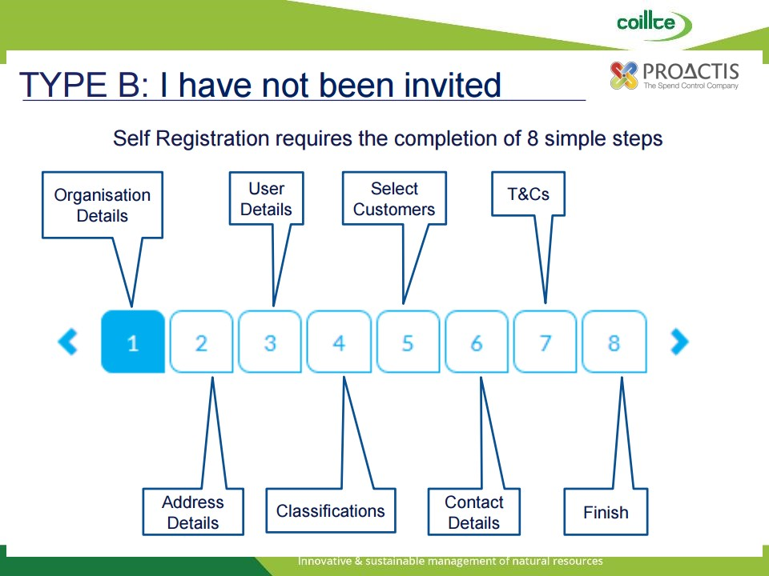 | - Self-Registration requires the completion of 8 Simple Steps as detailed here.
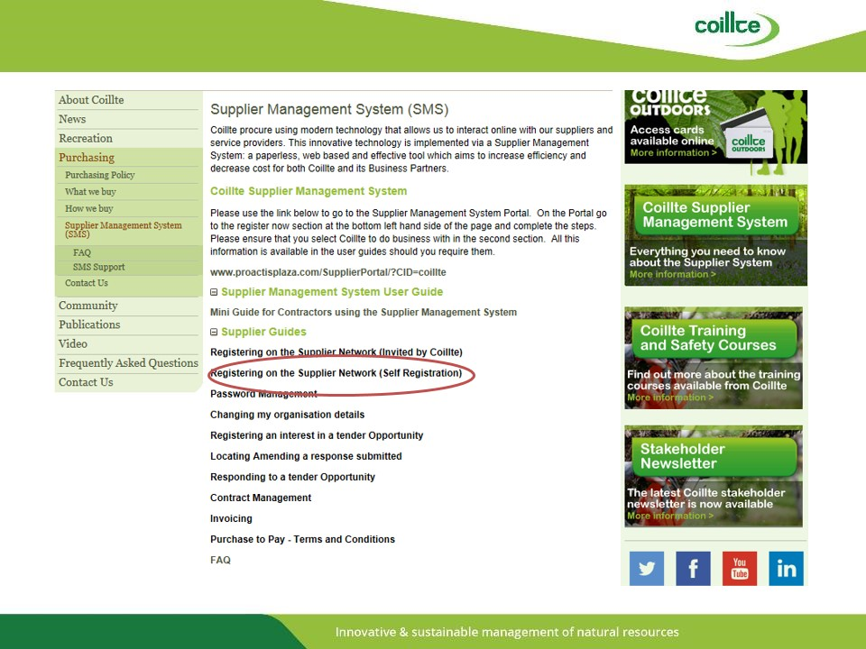 | - On www.coillte.ie  - It is recommended that you check the supplier guide “Registering on the Supplier Network (Self Registration)” circled in red on this slide.  - This supplier guide will provide you with detailed guidance on how to complete the 8 Simple Steps of the Registration process.
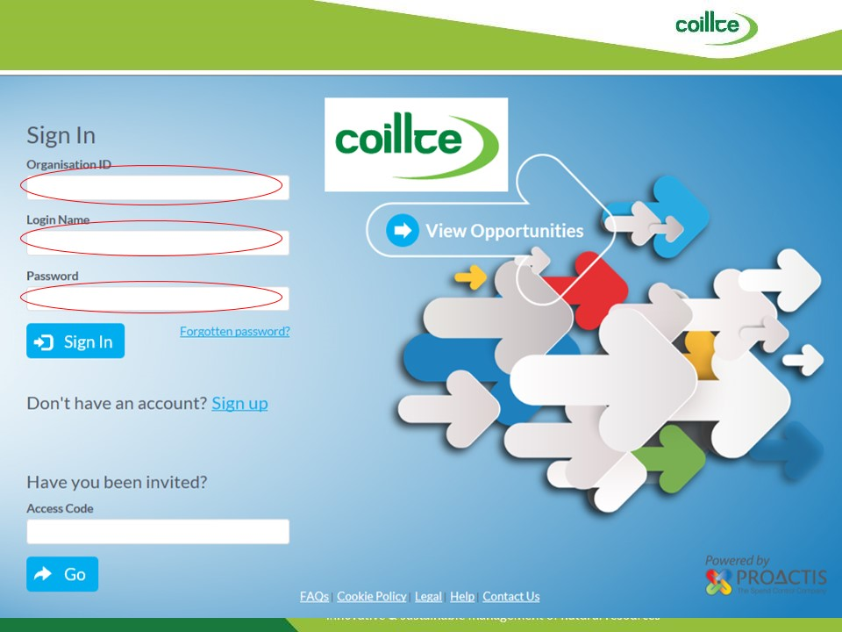 | - Once you have completed the registration process, you can launch the Proactis Web Portal clicking on the web link www.proactisplaza.com on Coillte’s website.  - You will then need to enter your login details to access the web portal.
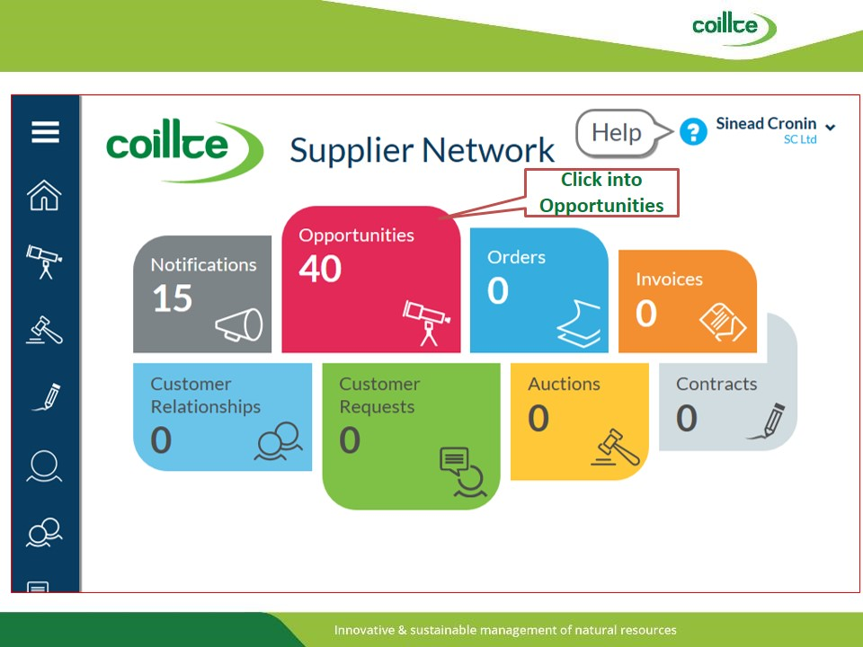 | - Click on the opportunities button to view your tendering opportunities.
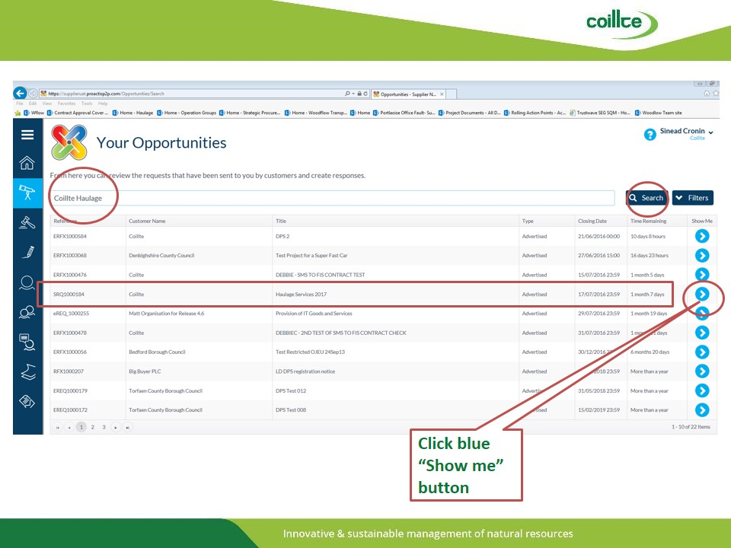 | - All opportunities will now be listed as displayed here.  - At the top of the slides you will see a search function for pinpointing your area of interest.  - By entering Haulage in the search function and clicking search, haulage opportunities will be highlighted.  - In this example you will click on the Blue Show Me button to take you to the next stage.
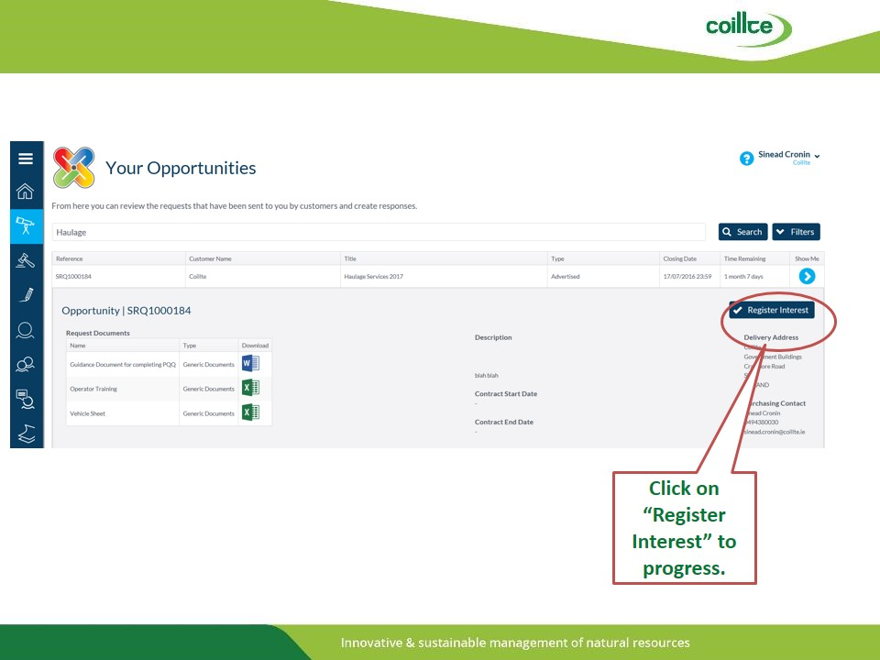 | - If this opportunity is of interest to you, click on Register Interest, circled in red here.
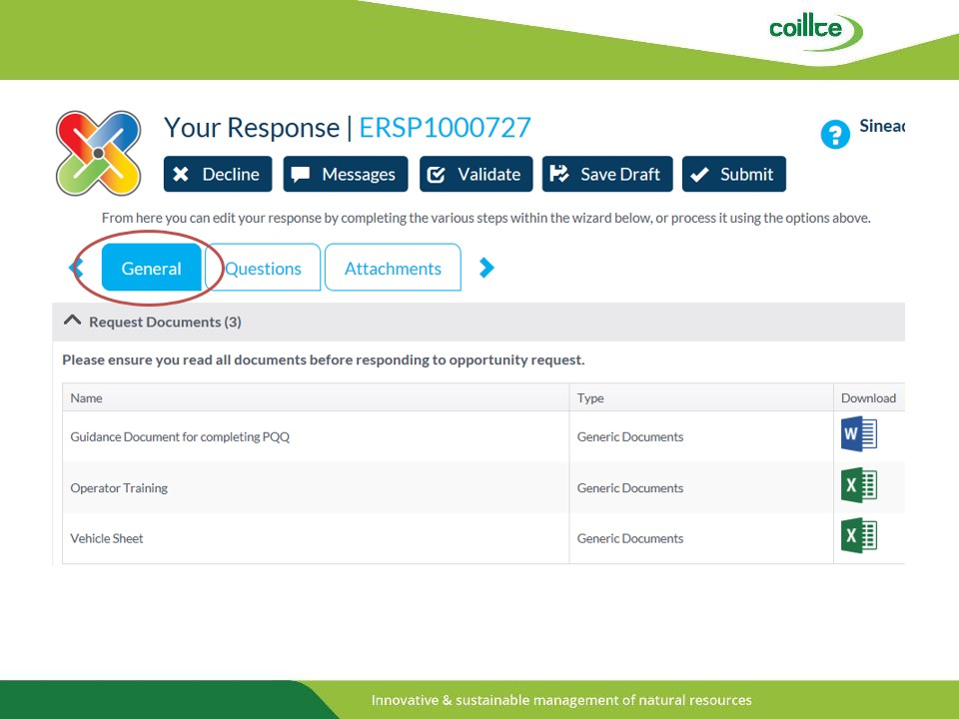 | - You will now have entered the section that allows you to progress with providing the necessary details to express an interest in tendering for Haulage Services to Coillte.  - In this example you will see 3 Tabs titled General, Questions and Attachments.  - By clicking the General Tab you will identify documents that are essential to the successful completion of the Pre-Qualification Questionnaire or PQQ, that must be completed if you are to be considered for Haulage Tendering opportunities later this year.
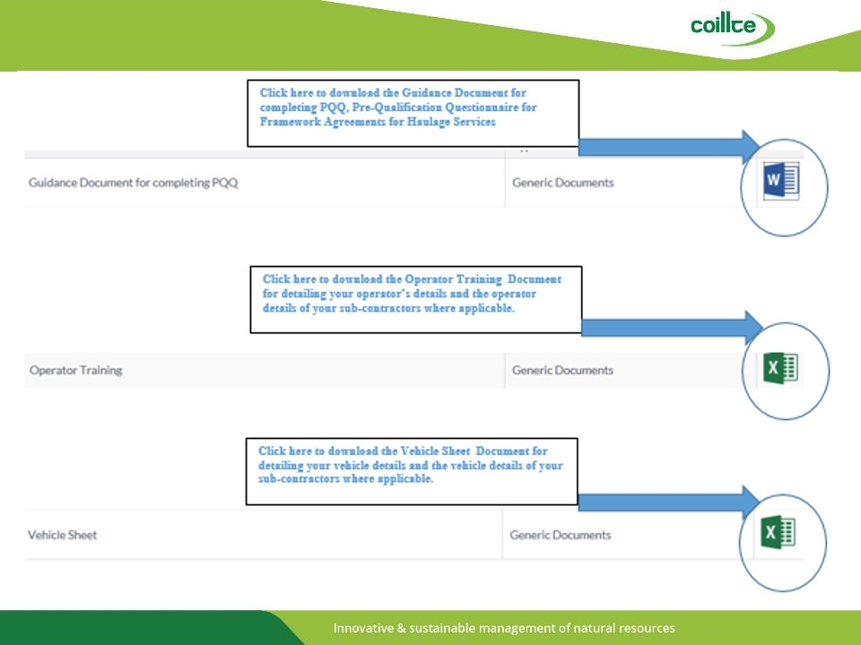 | - Each of these documents must be downloaded to your computer.  - The Guidance Document must be reviewed so that you understand the requirements of this PQQ.  - The Operator Training and Vehicle Sheet are two spreadsheets that must be populated with the details of the operators and vehicles that you intend to use if you are to be considered for a Haulage Services tender.  - Don’t forget to list the details of your sub-contractors on these spreadsheets if you intend to use any for a prospective tender.
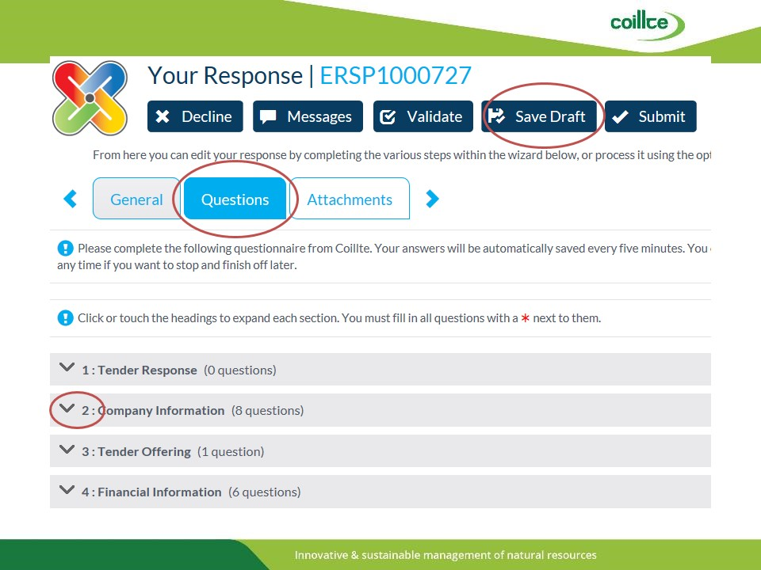 | - On completion of the General section and the saving of your operator and vehicle details to your computer, you will then click the Questions Tab.  - This tab will provide further information regarding the Pre-Qualification Questionnaire and it will also list the questions that need to be answered.  - By clicking on the arrow to the left of each Title, you will expand each section that will identify the questions that you need to answer.  - Upon answering a question please ensure that you click Save a Draft so that you save the detail that you have entered.
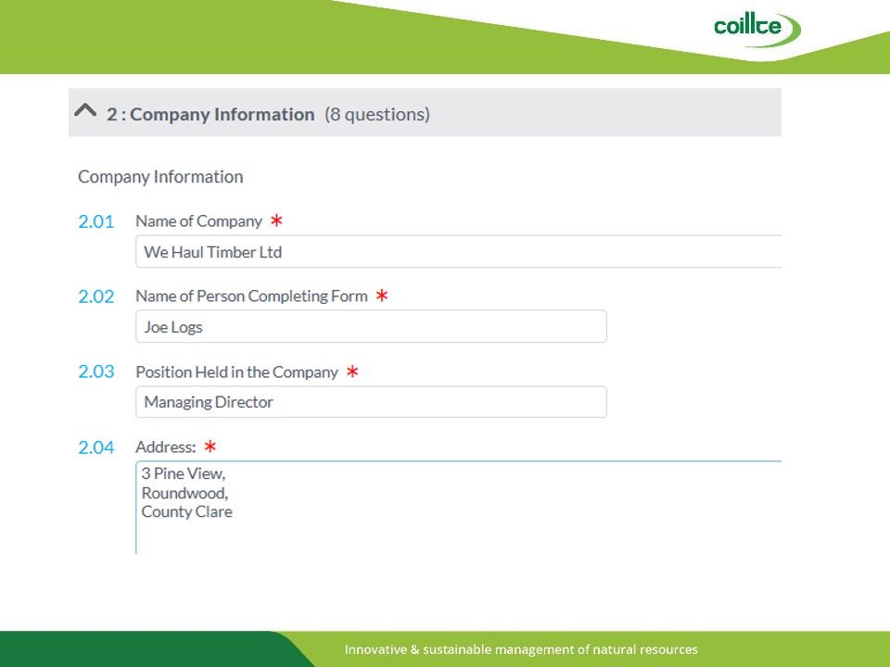 | - For example here we are viewing the section relating to questions on company information that have been answered.
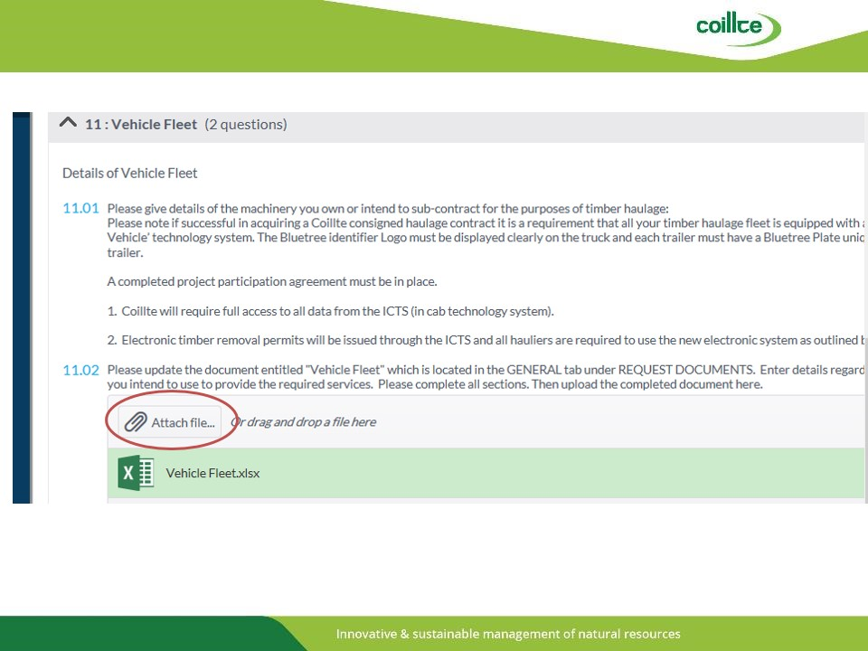 | - Some questions will require a document to be uploaded to complete the question.  - In this example you are required to attach the document that details your vehicle fleet.  - You can do so by clicking attach file, circled in red here, and following the steps to upload the document that you have pre-populated and saved to your computer.
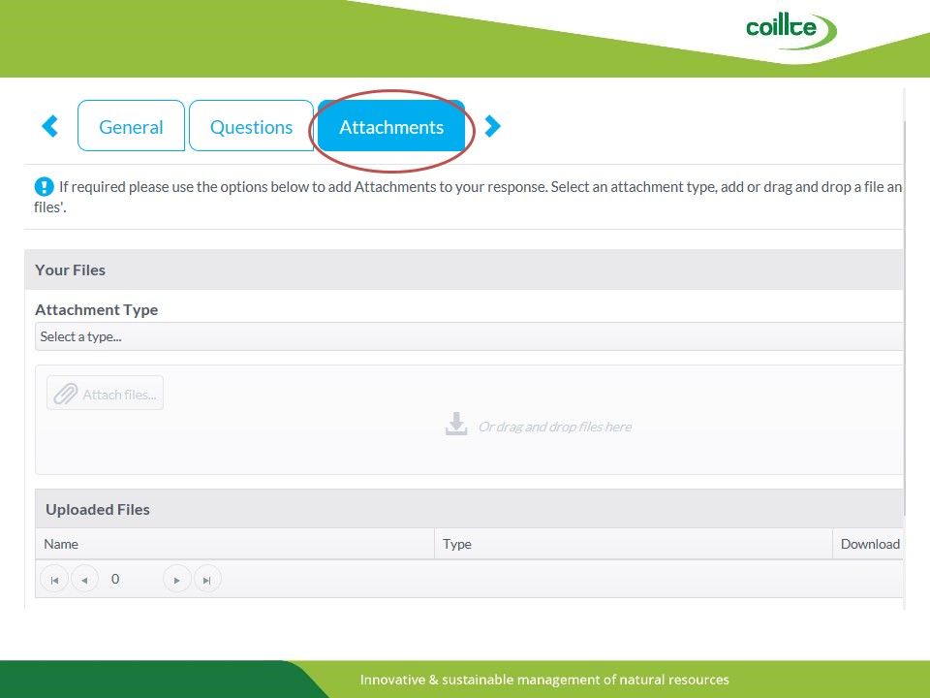 | - On completion of the Questions section you can then select the attachments tab.  - This section allows you to upload additional files that you may wish to add to the PQQ that you are submitting.
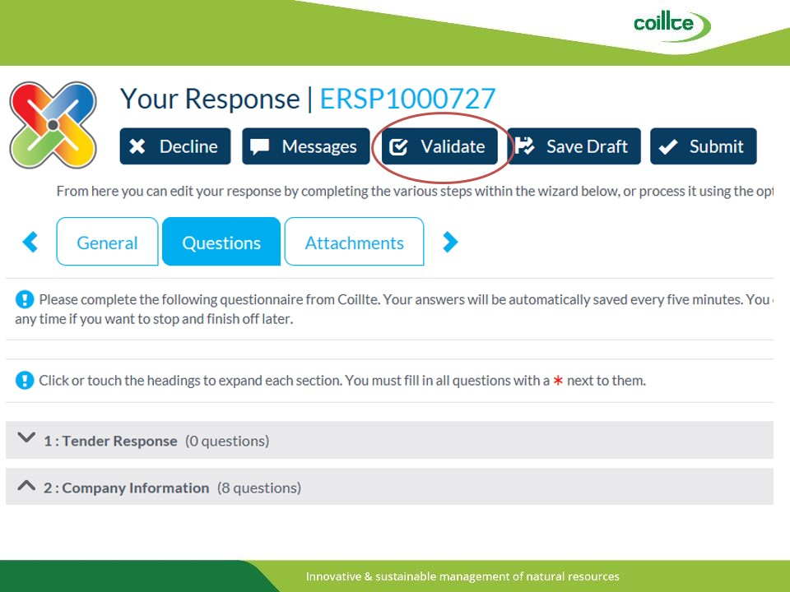 | - When you are satisfied that you have successfully populated the 3 tabs with the information required you will need to click the Validate button circled in Red here.  - This will identify if you have completed the PQQ with all of the required questions.
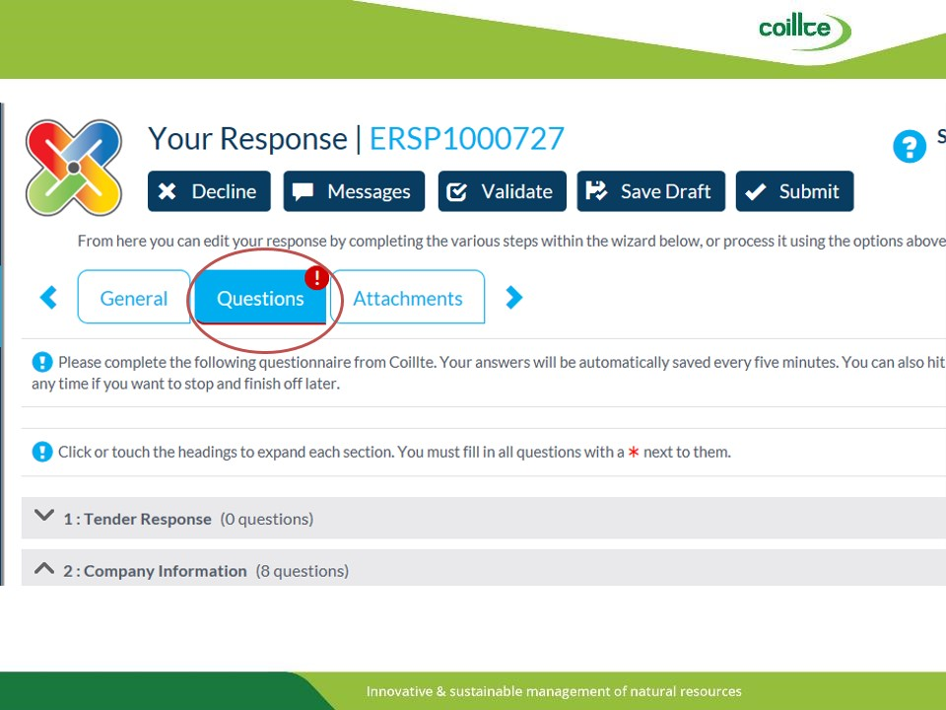 | - Here we see that the questions tab has a red exclamation mark.  - This identifies that there are questions that have not been fully completed.
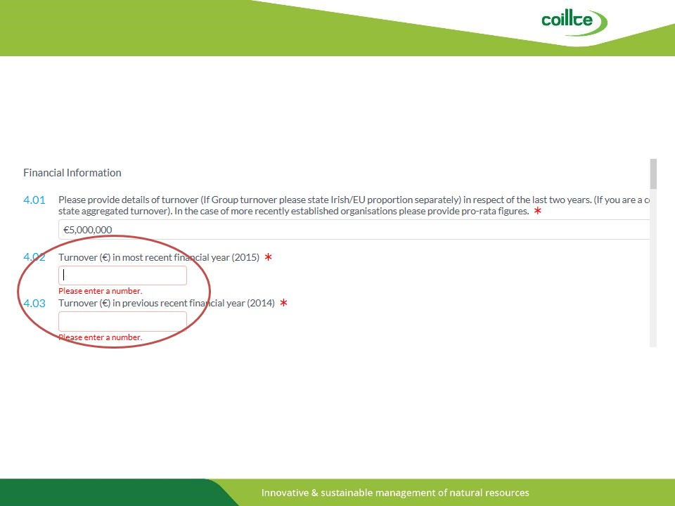 | - In this example the turnover for the previous financial years has not been populated as required.
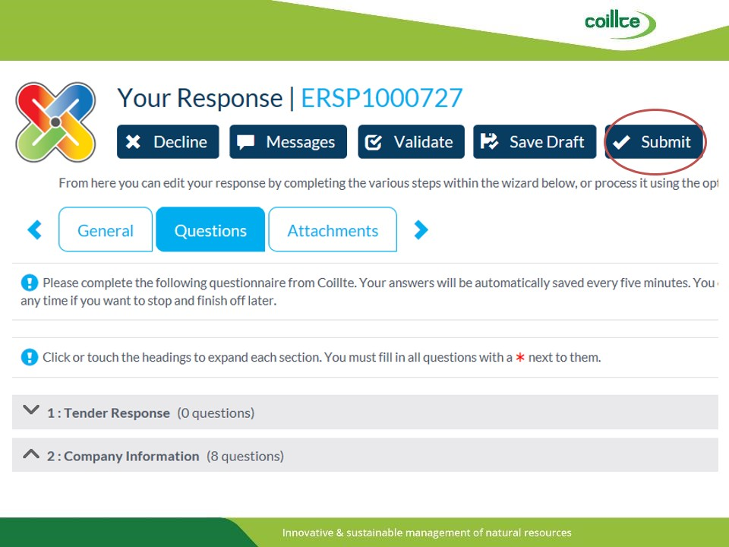 | - Once you have successfully validated your draft and you are satisfied that you have provided the correct information, you can proceed to click the Submit button to submit your completed PQQ.
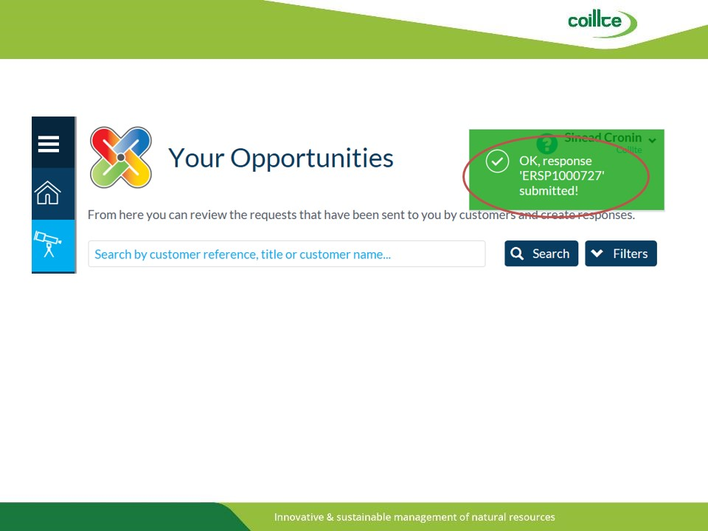 | - A green note identifying Ok Response will appear on the screen to confirm that you have successfully submitted your PQQ.  - It is extremely important that you see this note as it confirms that your submission has been received.
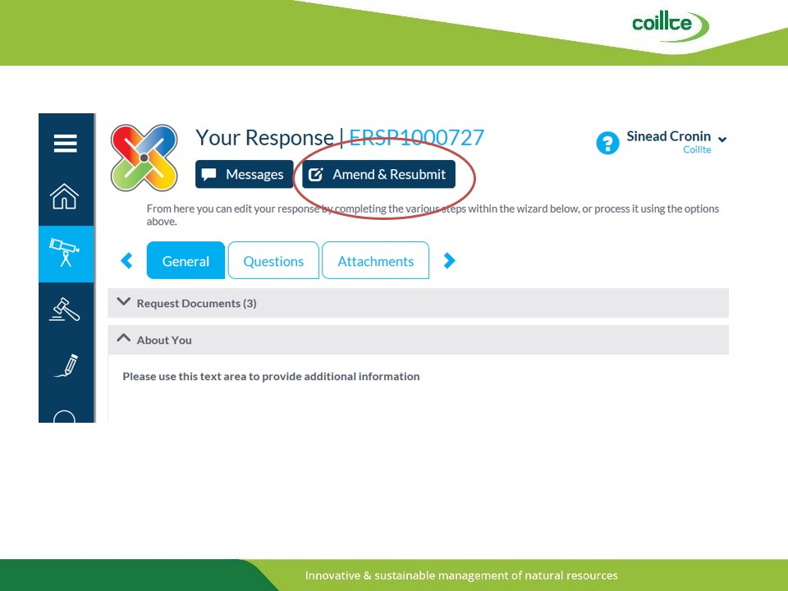 | - Prior to the closing date of the PQQ you can still Amend and Re-Submit your PQQ if you wish to make changes.  - To do so you must first click the Amend & Resubmit Button.
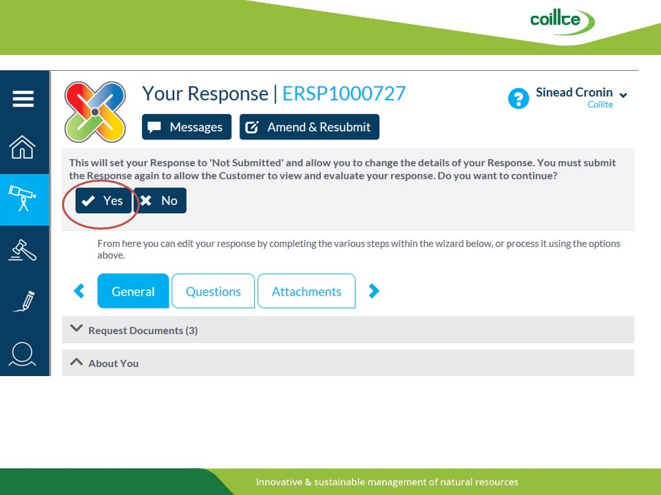 | - To make changes you will need to click the Yes button.  - Upon addressing the changes that you wish to make, you will need to follow the previous steps outlined to successfully complete your PQQ submission.
- 