Coillte Supplier Management System

Processing Invoices for payment

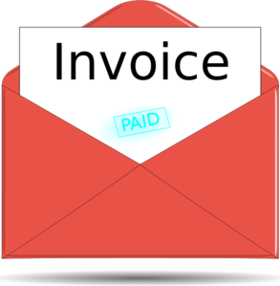

Information Guide SMS3

Introduction
Coillte introduced the Supplier Management system in 2013 to fully integrate and implement an electronic Purchase to Payment system including data management , e-tendering, contract authorisation, self invoicing and electronic payments system
Suppliers can use the system to complete all transactions with Coillte including:
- Register interest in doing business
- Maintain their master data and key documents
- Receive automatic notifications of Tenders
- Bid online for work
- Accept and authorise contracts electronically
- Generate invoices eletronically based on work certified/goods supplied
Information Guide
The purpose of this guide is to give suppliers a step by step approach as to how to use the SMS to process your monthly invoices for payment
Support
If you require any help in accessing or using the Supplier Portal please contact the SMS support team whose details can be found on the Coillte Website www.coillte.ie
1.
Logging in and out of Supplier Portal

Logging In
You can access your Supplier Portal via the link on the Coillte Main website see section 1.1 or by clicking on the following link
https://supplierlive.proactisp2p.com/Account/Login
Enter your email address as your Username and your password to open your Supplier Portal account
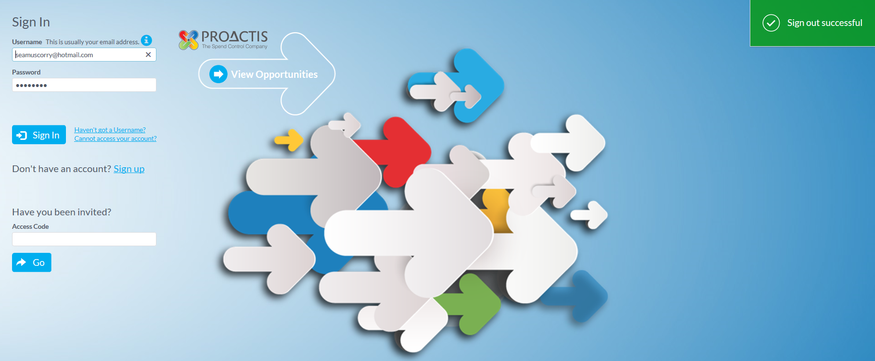

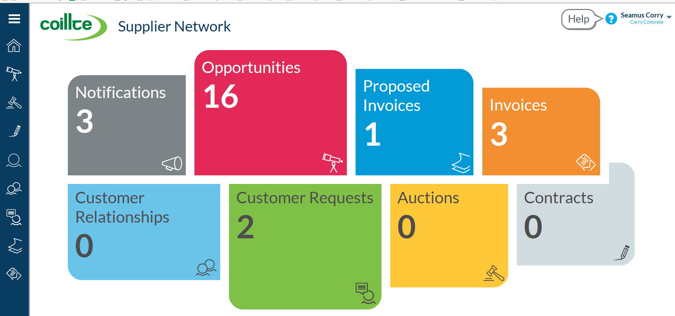

2.
Logging out
To log out select the drop down arrow on top right hand corner beside company name and click on sign out option to exit the system

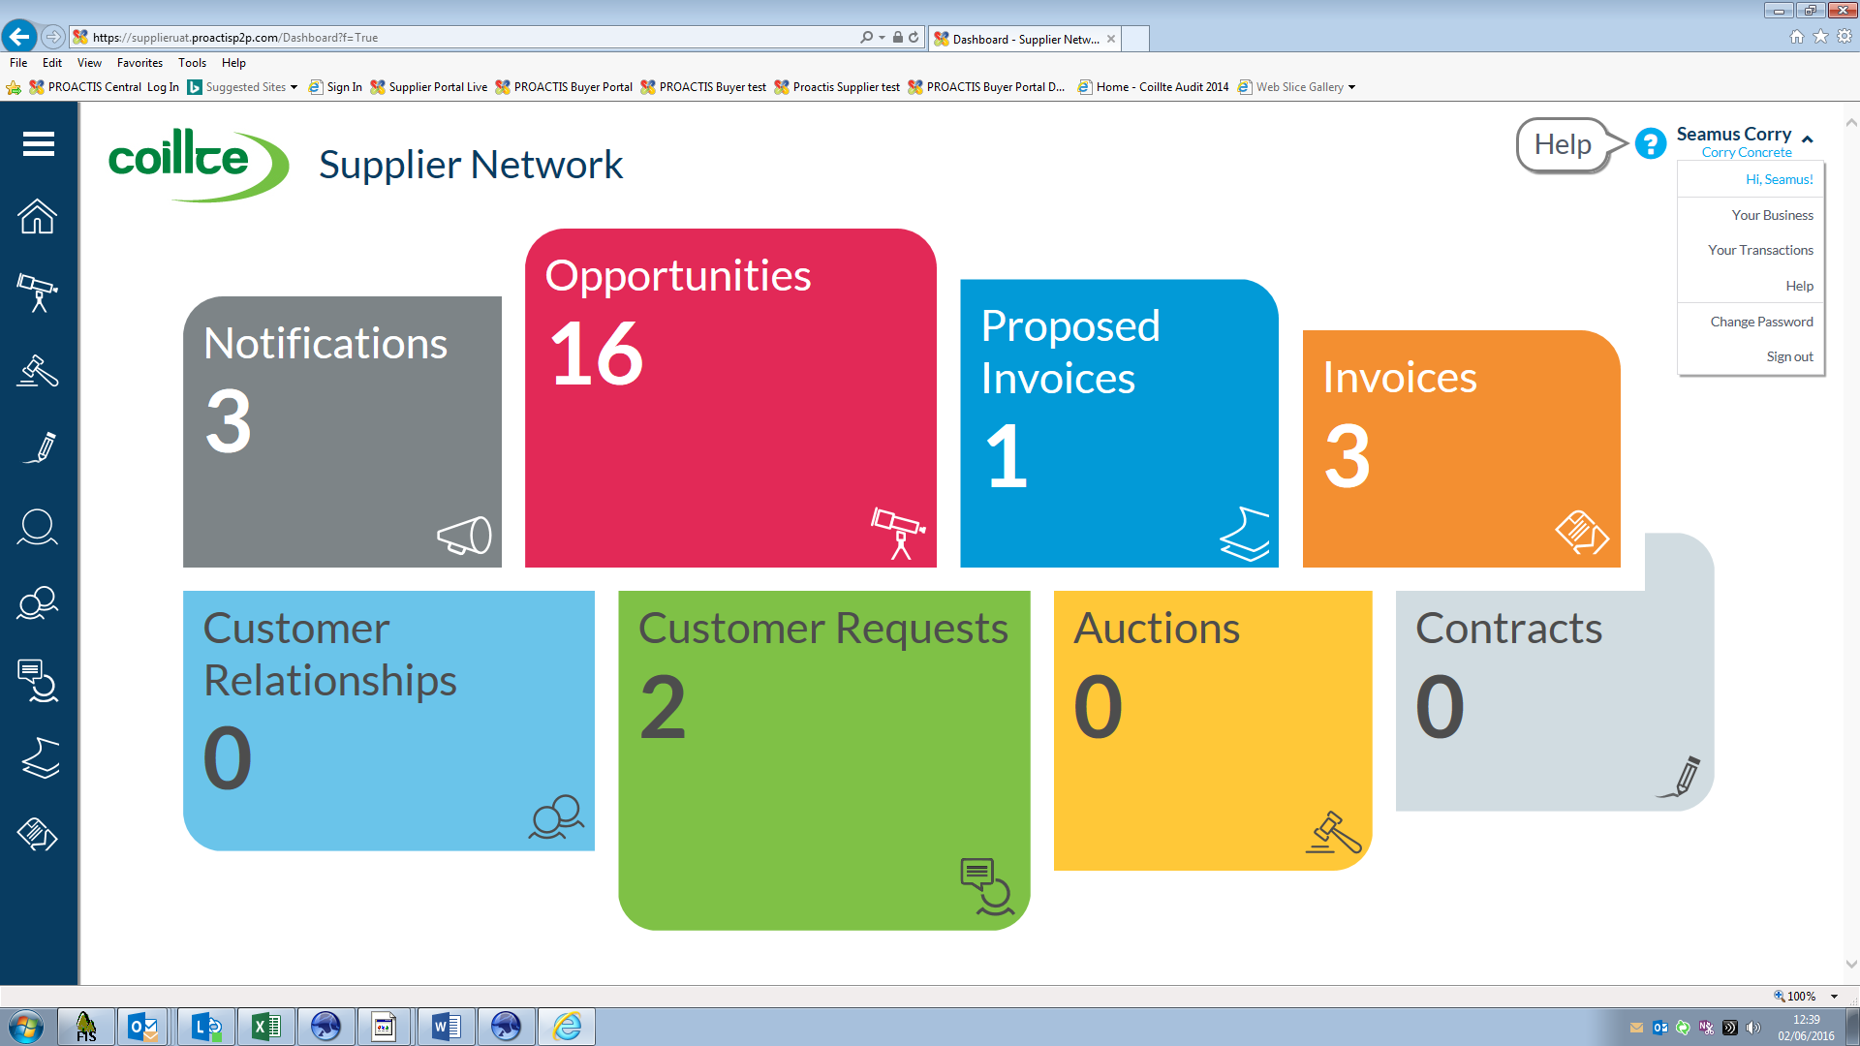

Forgot Username or Password
If you have any problems accessing the Supplier Portal please contact the SMS Support team or any member of the Accounts Payable team in Coillte at accountspayable@coillte.ie

3.
Certification /Notification of work done or goods delivered
The Contract Manager in Coillte will post a GRN /Contract Work Record ( CWR) in our contracts system for the work done or goods delivered in that month and the Supplier is notified by email that they have an invoice pending certification
Sample GRN / CWR
Sample email notification
Once you receive an email confirming a CWR ( GRN) has been processed to the Supplier Portal you can log into the Portal and convert that Order into an invoice which is the submitted to Coillte accounts for payment

4.
Processing invoices
When you log into the Supplier Portal you will find any unprocessed invoices in the Proposed Invoices menu
Click on this menu item

A list of invoices due to be processed by you will display
Click on the Show me arrow to view the invoice summary including CWR Number, quantity, Unit price, VAT and amount due to be paid

5.

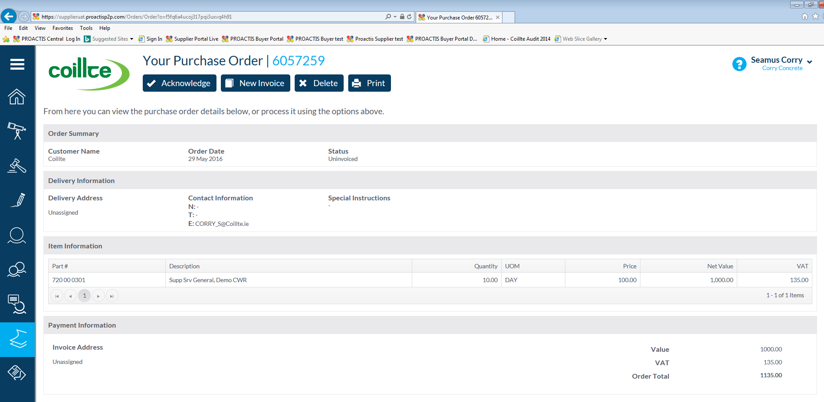
Click on the New Invoice tab to convert your GRN into an Invoice and you can then add your invoice number and amend the Invoice date if required . Once you are happy with the invoice Click on the Submit Button and this will automatically post your electronic invoice into the Coillte accounts and process in next payments run

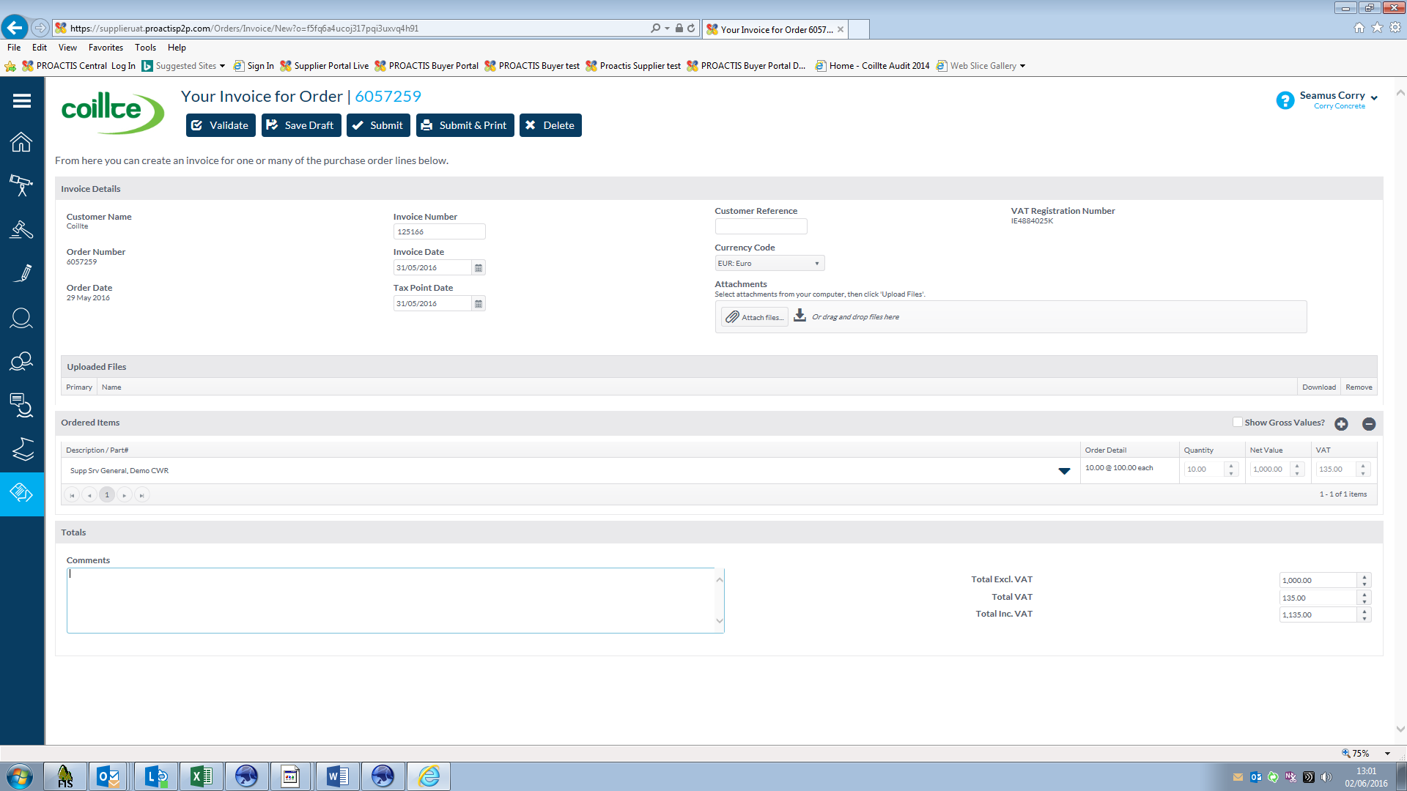
Note as Coillte pay invoices for contract work on a 15 days net of invoice date basis you should always enter the month end date as your invoice date to ensure prompt payment. For example if the work was done by your company or the goods supplied in June 2016 please put a date on invoice of 30th June or before to ensure it gets paid in the payments run on 15th July
6.
Invoices Processed records
To return to the main menu click on the House Icon on the dark Blue menu bar on left side of screen .
Your Unprocessed invoices have now been moved from the Proposed Invoices files to the Invoices file and can be viewed there , printed , emailed etc. so you have a complete record of all your invoices submitted to Coillte
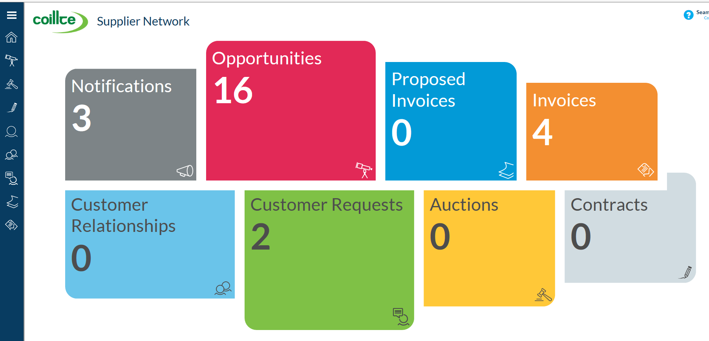

Sample list of Invoices processed
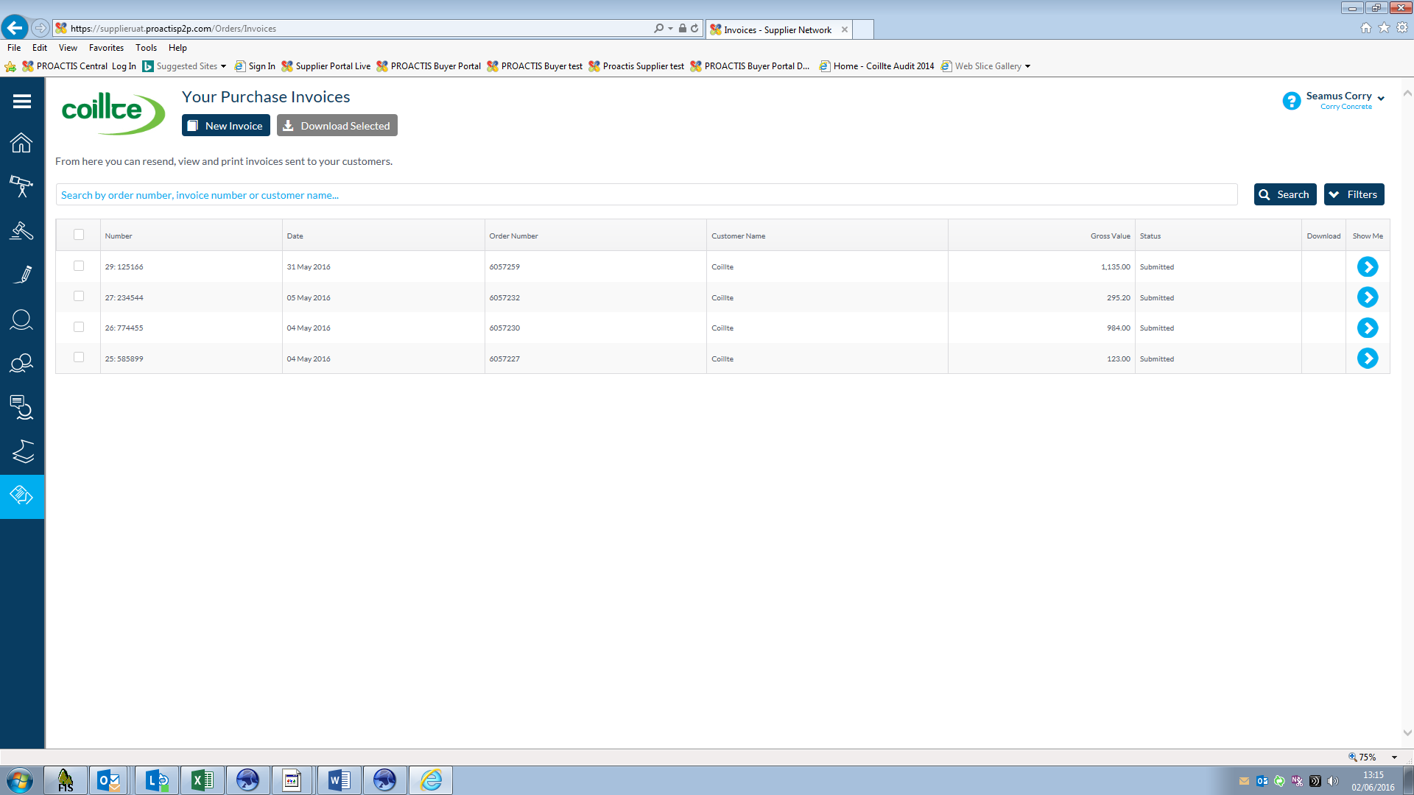

7.

Rejecting Invoice (s)
Log into the Supplier Portal as normal and select the invoice you wish to process in the Proposed Invoices menu.
If the proposed invoice is incorrect you can reject it by clicking on the Delete Button

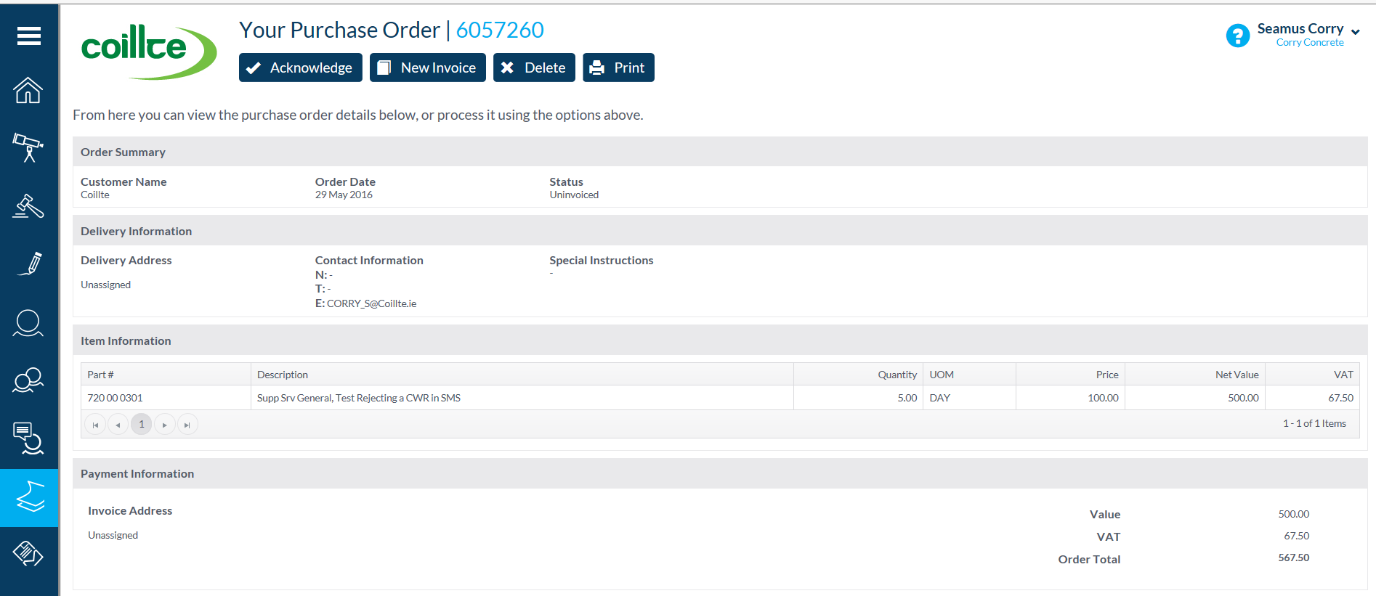
The System will prompt you to give a reason as to why you are not accepting the proposed invoice and automatically send an email to the Coillte Manager who certified the GRN/CWR to take relevant action

Please contact the Coillte Manager involved before deleting the Invoice to avoid any delays in processing any replacement invoice for payment

8.
Frequently Asked Questions (FAQs)
The following are some frequently asked questions in relation to the Proactis Supplier Management System and how to access and process invoices on it

Q. What do I if I cannot access the  Supplier Portal ? | Contact the SMS support desk by ringing (01)2011171 or emailing sms.support@coillte.ie or accountspayable@coillte.ie  And we will reset your password or give you whatever help you need in accessing the system
Q. I have my own accounting software  which generates its own invoices why  do I need to recreate them on the SMS ? | You can continue to use your own accounting software and generate invoices etc. but in order to get paid by Coillte you will have to generate the invoices and input your invoice numbers on the SMS
Q. Do I need to keep a copy of invoices  Submitted ? | No the Invoices you generate will be stored on the Supplier Portal and can be viewed, printed, emailed etc. at any time
Q. When will I get paid ? | Coillte pay its contractors on a monthly basis on the 15th day of each month unless the 15th falls on a weekend in which case the payment run is ran on the Friday . e.g. Work done in June is paid on 15th July
Q. What advantages are to me as a  a Supplier using the System ? | The main advantages of the system is that it is paperless cutting down on stationery and postage costs and you control when your invoice is processed for payment . Invoices can never be “ lost “ in the post and you can access the system 24/7 when it suits you and your business  Another big advantage is that Suppliers are paid quicker i.e. 15 days from month end compared to 60-90 days on Purchase Order system
Q. Are there many companies using the  Proactis system ? | There are thousands of companies worldwide using the Supplier  Management System and Coillte currently have approx. 1000 suppliers using the system to tender for work, authorise contracts and process invoices for payment
Q. Can I get paid by Cheque ? | The simple answer is No . Coillte have a policy of paying by electronic funds transfer direct to your bank account and we email you a Remittance Confirmation listing the invoices paid and deductions made
Q. Where can I get more Information on  the Supplier Management System ? | Log into the main Coillte website www.coillte.ie and click on the Supplier Management System link on the front page to access a wide range of training guides and other information . You can also view Coillte’s Terms and conditions here

9.

